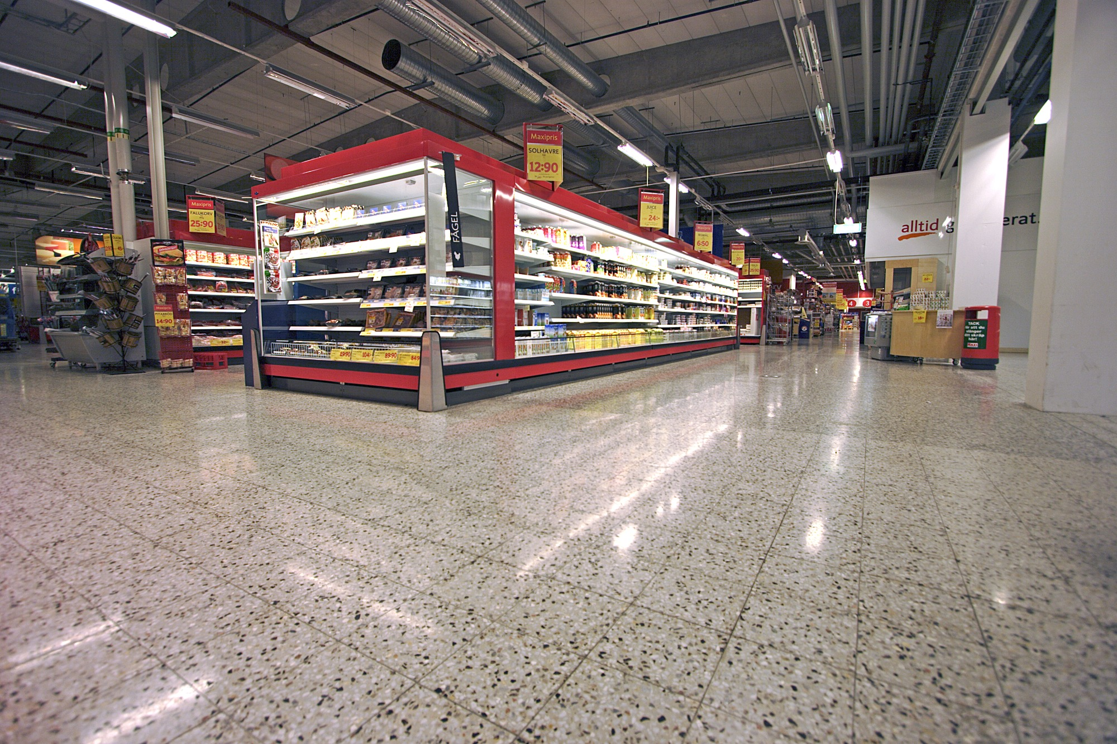


DIAMOND GRINDED / POLISHED SURFACES ( concrete, teracco )
- MAINTENANCE with HTC Twister™ pads

- What is Twister™

The unique Twister pads make the floor both cleaner and more attractive. The flexible Twister pads follow the floor's
contours, and by using billions of microscopic diamonds mechanically clean and polish the surface. No chemicals are needed for daily cleaning, just normal tap water. When the colour disappears from the pad, it is time to replace it.

- How does Twister™ work?

The combination of a soft floor maintenance pad and the hardness and sharpness of a diamond creates a unique product that follows the structure of the floor surface and effectively removes dirt at the same time as it polishes the surface. This creates the possibility of chemical free cleaning with high gloss every day.

- HTC Superfloor

Use HTC Twister pad green and normal scrubbing machine with water for daily maintenance of concrete / teracco polished surface. To achieve higher gloss, you can use HTC Twister green and high-speed machine (dry process) without chemicals. Twister pads are designed up to 3500 rpm.

Sizes HTC Twister™ pads
Hand Twister™ pads 25 x 12,5cm
Twister™ pads for cleaning machines 4” – 28” ( 10 – 71cm )

Exlusive representative HTC Sweden AB for Czech Republic and Slovakia:

REDIMAX spol. s r.o.
Teslova 12
CZ - 301 00 Plzeň

Michal Papež +420 606 628 781

www.redimax.cz papez@redimax.cz

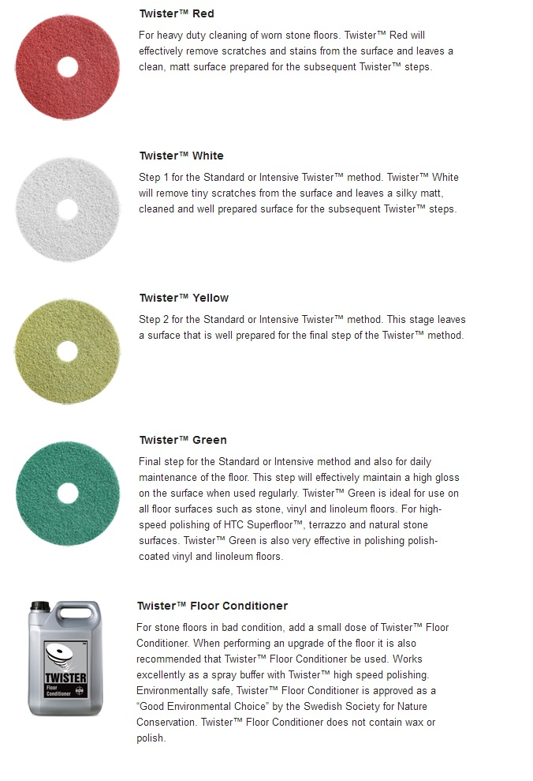

Redimax spol. s r.o., Teslova 12, 301 00 Plzeň www.redimax.cz redimax@redimax.cz

- Twister – use
Pic. 1 – Get rid of surface finish from dirt
Pic. 2 – The color side is working and also serves as a wear indicator
Pic. 3 – Put Twister to plate for pads
Pic. 4 – Fill the tank with clean water
Pic. 5 – Start with mechanical cleaning
Pic. 6 - After the end rinse the pad

Redimax spol. s r.o., Teslova 12, 301 00 Plzeň www.redimax.cz redimax@redimax.cz

