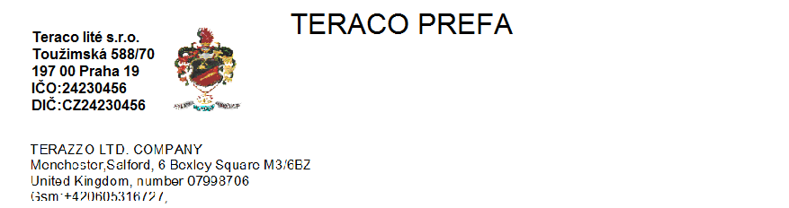

Teraco´s stairs and other boards are made with technology of high frequency vibrated one-layer prefabricates with cut and polished surface. All products are reinforced with concrete reinforcement, supporting elements are reinforced according to static calculation..
Stairs L-profile
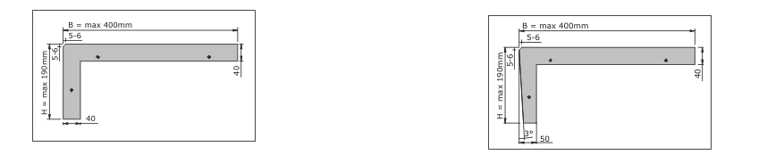
Type LS with perpendicular subscale Type LSS with undercut subscale

Step-on stairs + subscale 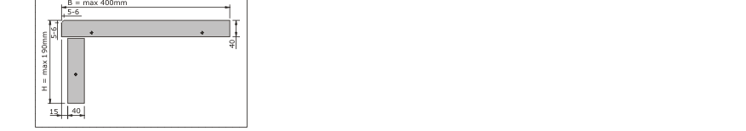
Board stairs type SD

Wedge stairs 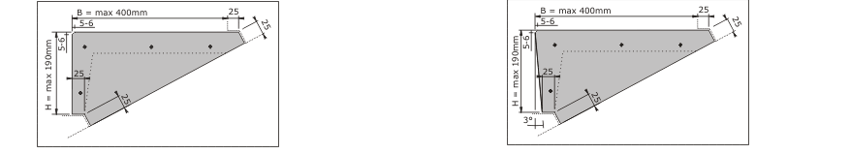
Type KS with perpendicular subscale Type KSS with undercut subscale

