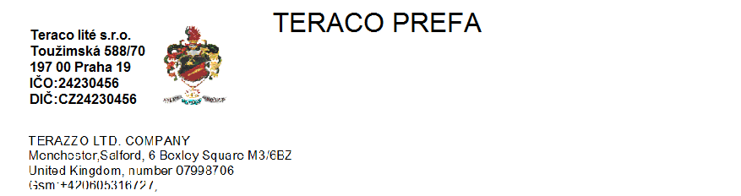
Atypical stairs
Rounded, undercut, made based on templates delivered from customer or optimized from TESO company
Stairs L-profile 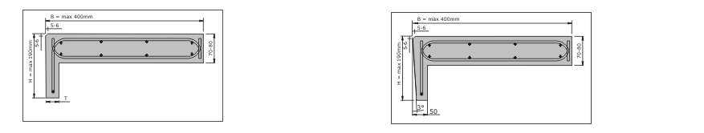
Type LS with perpendicular subscale Type LSS with undercut subscale

Stair step-on + subscale 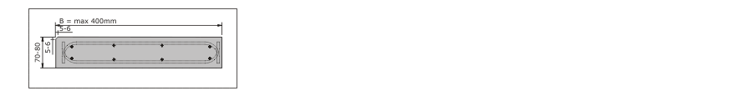
Support step-on

Wedge stairs 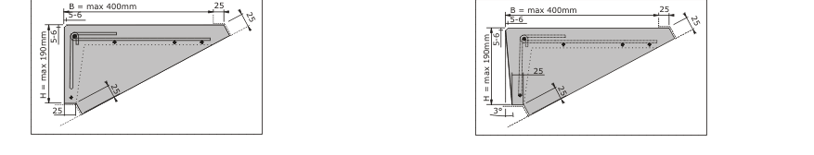
Type KS with perpendicular subscale Type KSS with undercut subscale

